# **Doctor Appointment System**

## **Contributor**

|  |  |
| --- | --- |
| **Name** | **Email** |
| Vishwajit Nikam | [vishwajit.nikam@ibm.com](mailto:vishwajit.nikam@ibm.com) |

## **System Architecture**

#### **Backend**

* **Framework**: ASP.NET Core 9 Web API   
    
  Responsibilities
  + Exposes RESTful endpoints for patient and doctor appointment and schedule management
  + Handles business logic (Patient registration and book appointment, Doctor manage appointment, Doctor create and update schedules)
  + Uses **Entity Framework Core** for ORM

#### **Frontend**

* **Framework**: React (with Bootstrap for styling) React version 19.

Responsibilities

* + User Interface for patient and doctor
  + Handles login, patient registration /book appointment, doctor manage appointments and create/update schedule.
  + Uses **React Router** for navigation
  + Uses **Axios** for API request
  + Communicates with backend via **RESTful APIs**

#### **Database Layer**

* Database: SQL Server

**Includes tables:**

* Patient
* Doctor
* Appointment
* DocotorScheduleAppointment

**Includes Stored Procedure:**

* GetAllAppointment
* GetAllDoctorSchedule
* GetAppointmentsByDoctor
* GetAppointmentsByPatient
* GetDoctorSchedule
* GetUserDetails
* InsertAppointment
* InsertDoctorScheduleAppointment
* Registration
* UpdateAppointmentByDoctor
* UpdateDoctorScheduleAppointment
* UpdateDoctorScheduleStatus

## **Folder Design**

### Frontend folder structure:

### Backend Folder Structure:

## UI Components

**Registration Page  
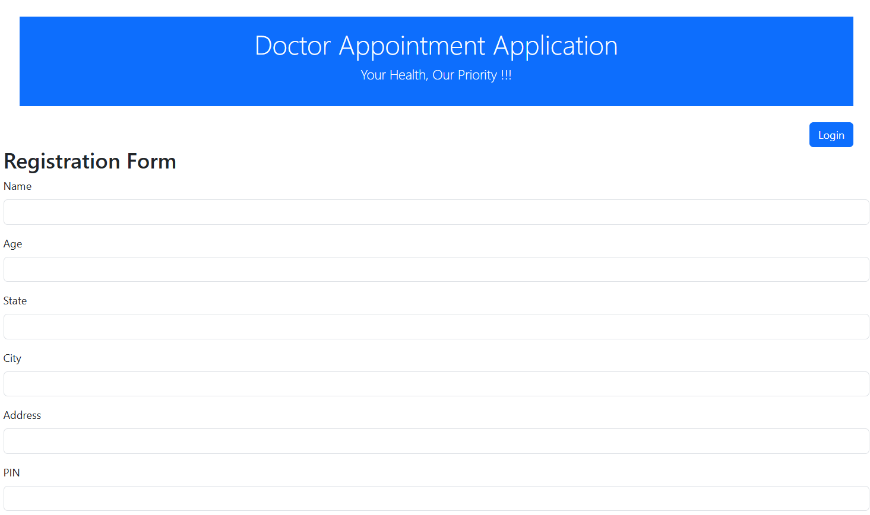

**Login Page**

**Patient Appointment**

**Patient Dashboard**

**Doctor Dashboard**

**Doctor Schedule appointment**

**Doctor Schedule List**

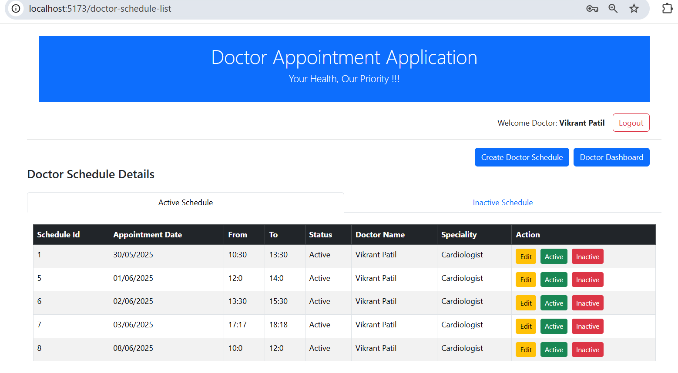

**Edit schedule doctor appointment**

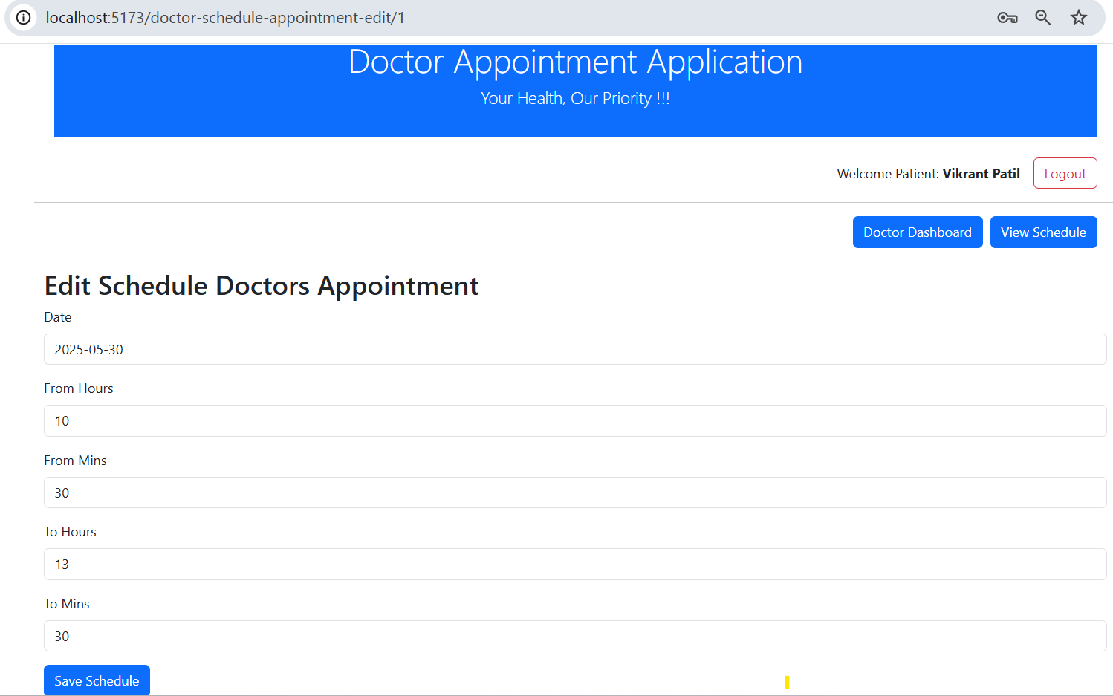

**User Name / Password**

|  |  |  |
| --- | --- | --- |
| User Type | User Name | Password |
| Patient | Harbhajan | harbhajan123 |
| Doctor | Vikrant | vikrant123 |